BIT4107 Project Progress Documentation
Week 1: Environment Setup
I successfully configured the Flutter development environment and created the foundational "Hello World" application.
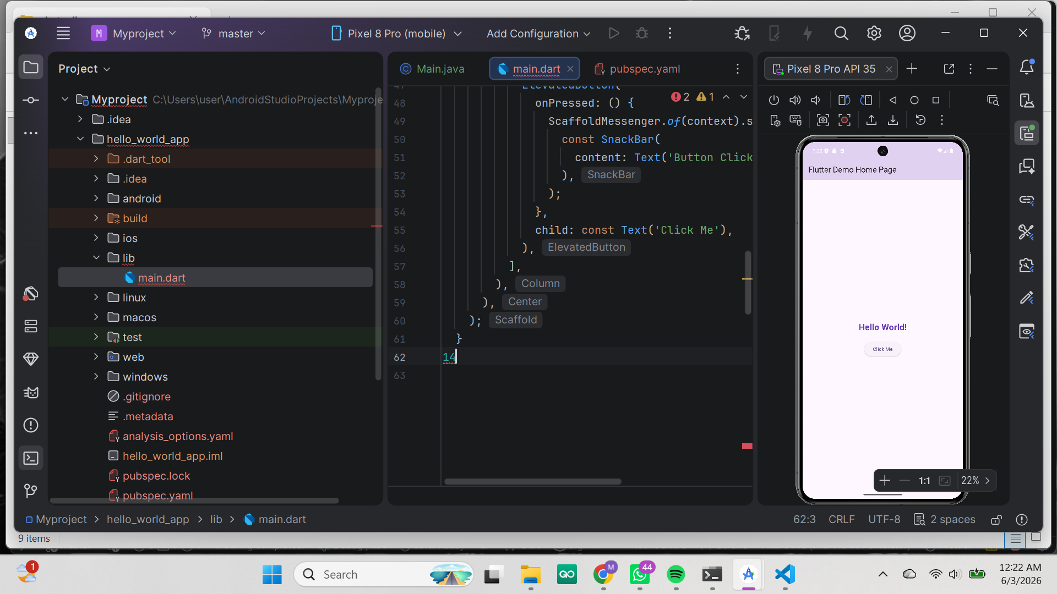
Fig1:hello world

Week 2: Project Architecture
I established the core directory structure and package organization for the Student Management application.
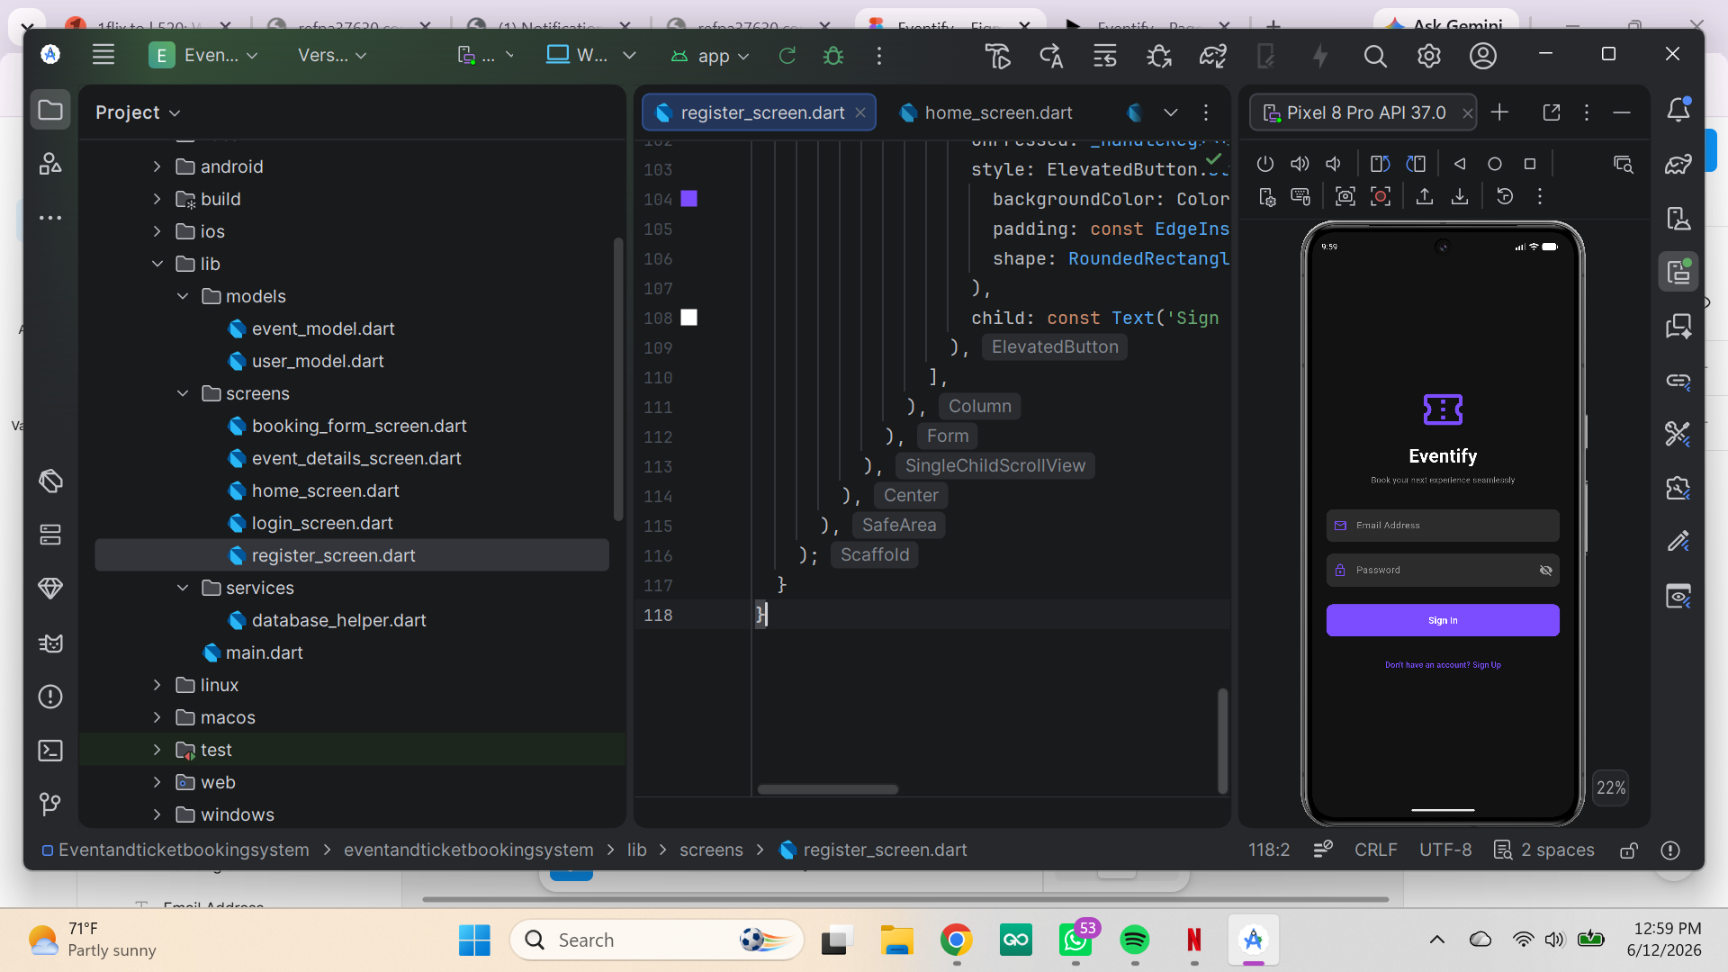
Fig2:login screen

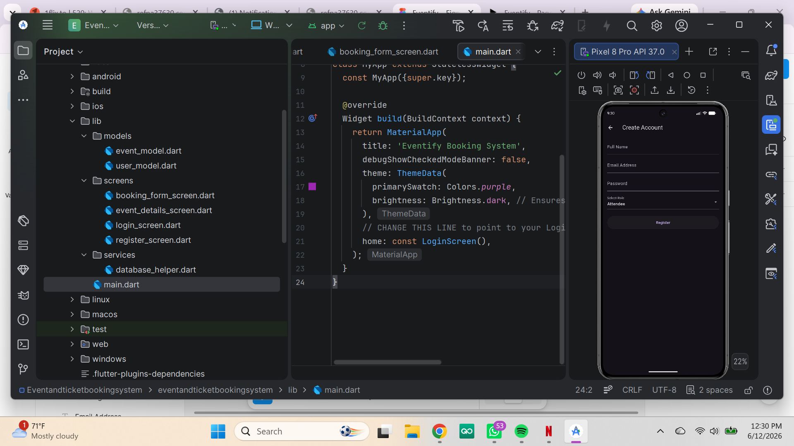
Fig3: registration screen

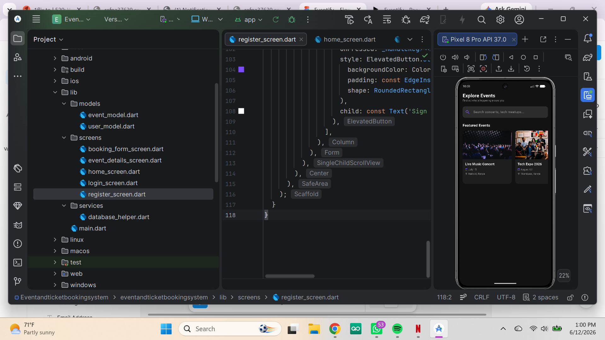
Fig 4: home_screen

Week 3: User Interface Design
I designed and implemented the user authentication interface and the main dashboard navigation screens.

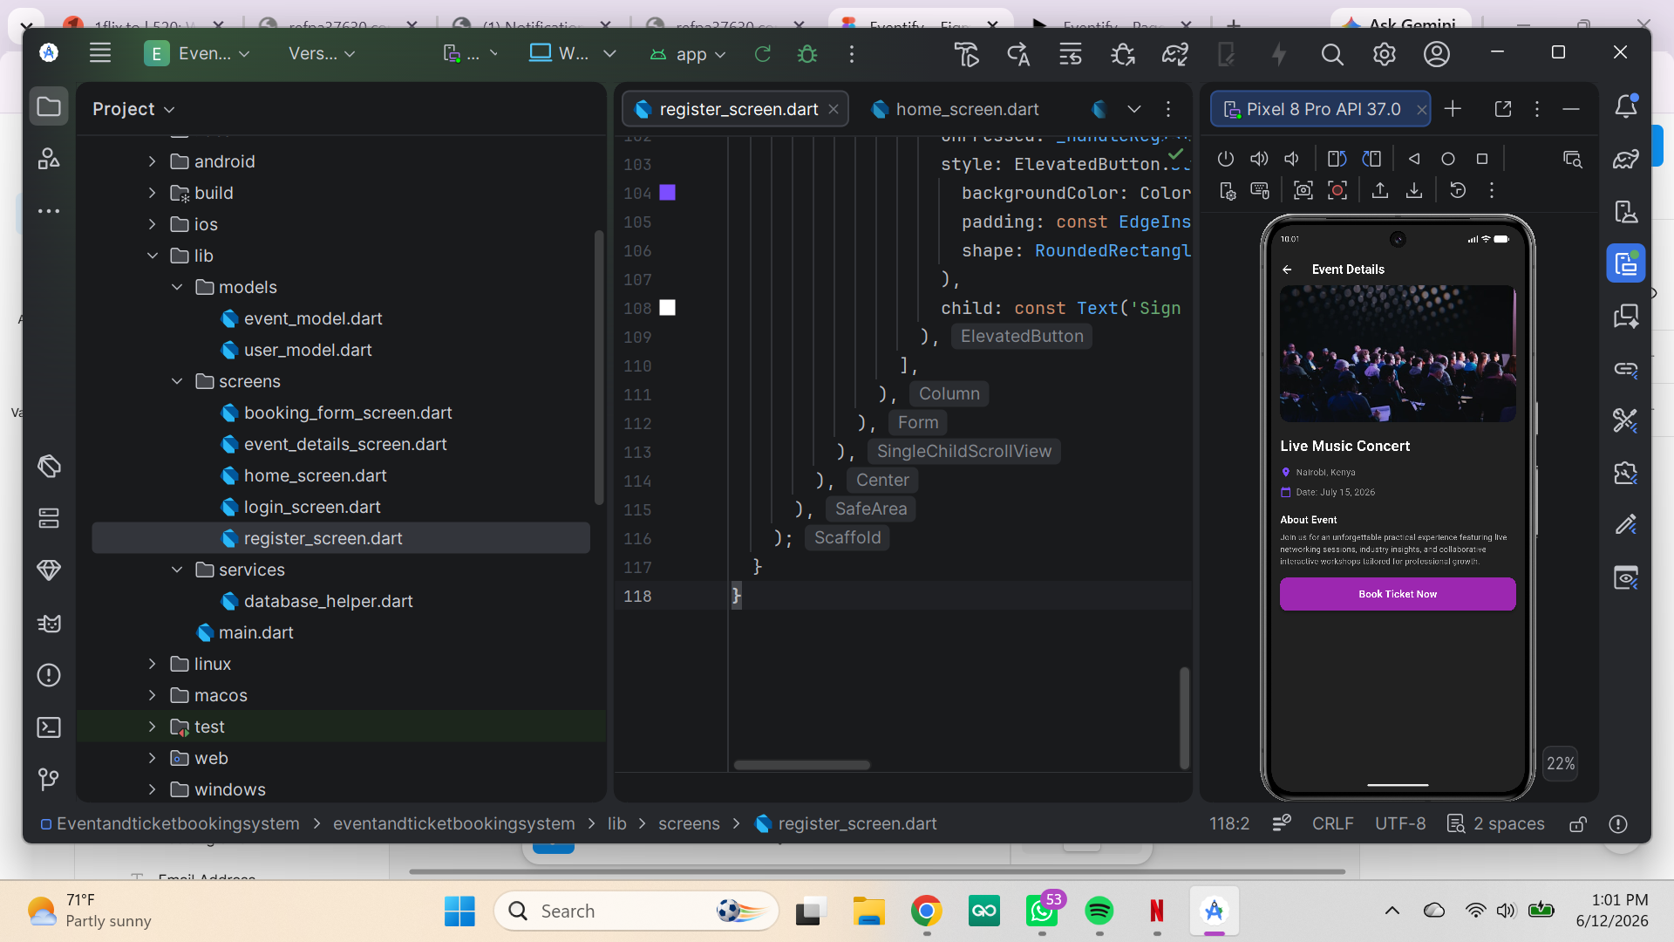

Fig 4: Event details screen

Fig 5: booking form

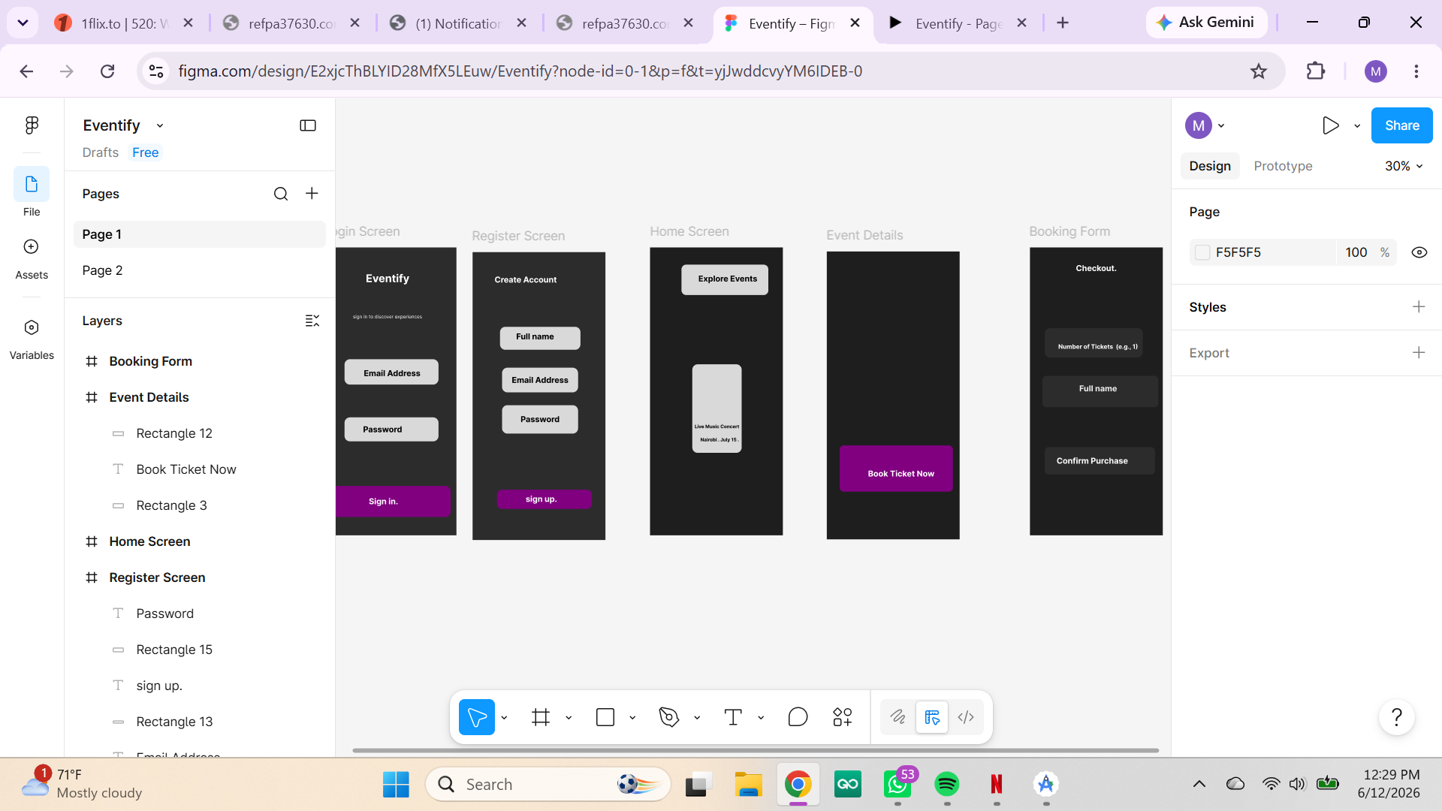
Fig 6: Figma
Week 4: Local Database Integration
I created the SQLite database helper class to handle secure, local data storage operations.

Fig : database helper screen

Week 5: Code Optimization & Debugging
I resolved all Gradle build issues and fixed the Dart analysis errors to ensure a clean, functional application compilation.

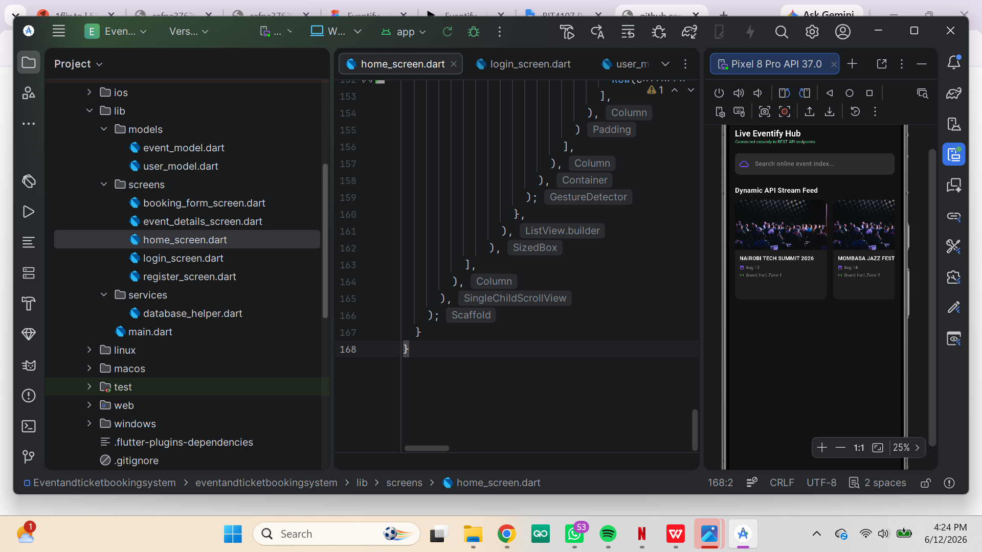

Fig7 :API feed

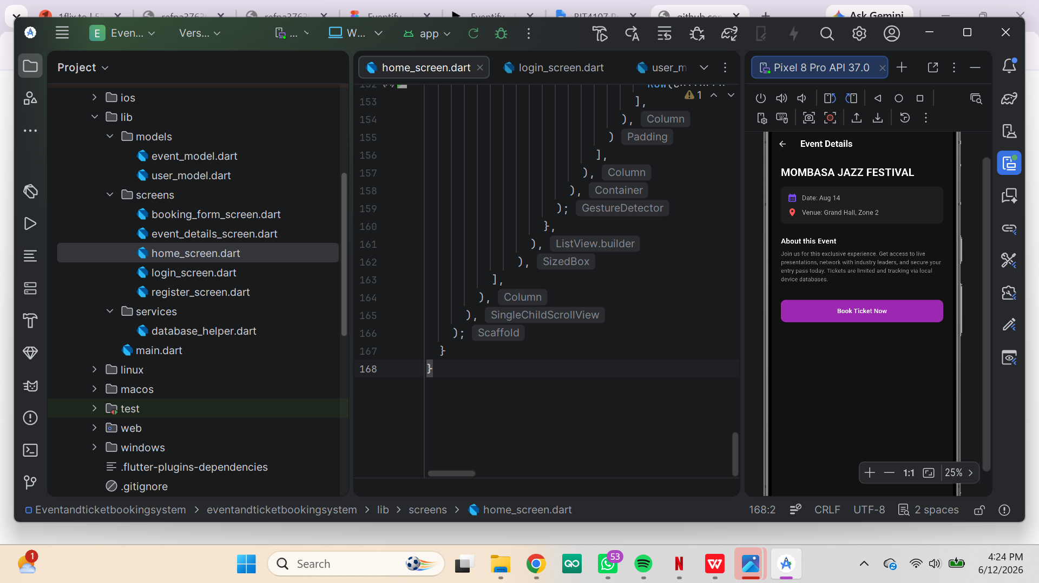
Fig 8: rest data

